JAVA-8
what is Lambda Expressions?
Lambda Expressions can be defined as methods without names i.e. anonymous functions. Like methods, they can have parameters, a body, a return type and possible list of exceptions that can be thrown. But unlike methods, neither they have names nor they are associated with any particular class.
Syntax: Lambda syntax consists of three parts – list of parameters, an arrow mark and a body. The body of a lambda can be an expression or a set of statements. If it is set of statements, they must be enclosed within curly braces { }. Return type and possible list of exceptions that can be thrown are not explicitly mentioned in a lambda. They are implicitly applied.
->A lambda expression is a short block of code which takes in parameters and returns a value. Lambda expressions are similar to methods. but they do not need a name and they can be implemented right in the body of a method.
-> Lambda Expression can implement in Functional Interface which contains a single abstract method.
Lambda expressions can only be used to implement functional interfaces—interfaces with exactly one abstract method.
->Lambda expressions are used where an instance of functional interface is expected.
->we can use Lambda Expression we can write more concise and flexible code.
A lambda expression is an anonymous function.
A function that does not have a name and does not belong to any class is
called as anonymous function.
->A function that can be shared or referred to as an object.
->To use Lambda depression, you need to either create your own
functional interface or use the pre defined functional interface
provided by java.

- It is a process of writing method logic in less lines of code.
- It reduces number of lines of code.
- It works faster than previous process.
- It saves memory and execution time by reducing creation of object(s).

Functional Interface
Functional interfaces, lambda expressions and Stream API – these three features of Java 8 has turned Java programming into new style of programming called functional-style programming. Java is still an object-oriented programming language, but from Java 8, with the introduction of new features, most of the programming is done keeping functions in mind rather than objects. In this article,. we will see Java 8 functional interfaces, @FunctionalInterface annotation, java.util.function package and how to use new Java 8 functional interfaces to compose lambda expressions with some simple examples.
What is Functional Interface ?
A functional interface is an interface which contains exactly contain only one abstract method. It can perform only one functionality. Lambda expressions are used to represent the functional interface. Referred also as Single Abstract Method(SAM) Interfaces. This was included in Java8 along with lambda expressions to make code more readable and cleaner.
• Functional interface can have any number of
- Default methods
- Static methods
- Methods inherited from Object class
• Functional interfaces are represented, used and executed with an annotation called @FunctionalInterface.
• @FunctionalInterface annotation is used to ensure that the functional interfaces can't have more than one abstract method. In case more than one abstract methods are present, the compiler flags an 'Unexpected @FunctionalInterface annotation' message. Using this annotation is optional.

- An Interface with exactly one abstract method but can have multiple default and static methods is called Functional Interface. to represent functional interface we will use @FunctionalInterface annotation.
Ex: Runnable, Callable and Comparable these are the pre define Functional Interfaces.
Predefined Functional Interfaces:
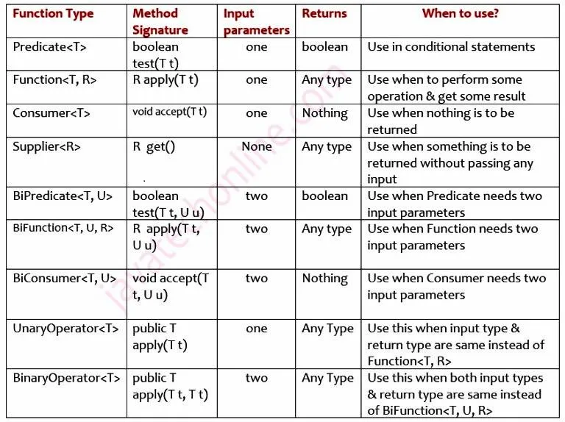
Predicate<T>
Predicate is a predefine Functional Interface. we can use Predicate<T> to implement some conditional checks. However, from it’s method signature : boolean test(T t) it is clear that it takes an input parameter and returns a Boolean result. When you have this type of requirement to write a method, use it confidently. Let’s observe the method signature as below:
public interface Predicate<T> {
boolean test(T t);
}

Ex: Predicate<Integer> p = (i) -> (i > -10) && (i < 10);
System.out.println(p.test(9));

Function<T, R>
Function<T, R> it’s taking input, performing some operation & returning result, Function<T, R> can return any type of value.
interface Function<T,R> {
R apply(T t);
}

Ex: Function<String, Integer> f = s -> s.length();
System.out.println(f.apply("I am happy now"));

Consumer<T>
Consumer<T> is used when we have to provide some input parameter, perform certain operation, but don’t need to return anything. Moreover, we can use Consumer to consume object and perform certain operation.
interface Consumer<T> {
void accept(T t);
}
Ex: Consumer<String> c = s -> System.out.println(s);
c.accept("I consume data but don't return anything");

Supplier<R>
Supplier<R> doesn’t take any input and it always returns some object. However, we use it when we need to get some value based on some operation like supply Random numbers, supply Random OTPs, supply Random Passwords etc. For example, below code denotes it :
interface Supplier<R>{
R get();
}

Ex: Supplier<String> otps = () -> {
String otp = "";
for (int i = 1; i <= 4; i++) {
otp = otp + (int) (Math.random() * 10);
}
return otp;
};
System.out.println(otps.get());

What is default and Static methods in interface?
- Default Methods: Interfaces can have default methods along with the abstract methods. A default method is declared with the keyword default. Default methods must have a body, and it is optional for the classes implementing that interface to override them.
- To add new methods to interfaces without breaking the classes that already implement them.
- Provides method implementation inside the interface itself.
- Useful when you want to add new behavior to existing interfaces without forcing all implementing classes to override it.
- Default methods enable you to add new functionality to existing interfaces and ensure compatibility older versions of those interfaces.
- Default methods enable you to add methods that accept lambda expressions as parameters to existing interfaces.
- Static Methods: We can have static methods in our interface. They are like default methods; except that we can't override them in the implementing classes. They are used to provide a generic, or well written implementation which we do not want our implementing classes to change.
- To define utility/helper methods related to the interface.
- Cannot be overridden or inherited by implementing classes.
- Useful for grouping related helper methods within the interface itself.

Resolution of Diamond Problem in context of Default methods
As all of us know that Java doesn’t support multiple inheritance & we make use of interfaces in place of classes to get this feature to some extent. Suppose we have two interfaces A & B and both of them are having the default method m1() with the same method signature. Our implementing class is going to implement both the interfaces to have multiple inheritance feature. Now compiler will start complaining as it will not be able to understand m1() method of which interface needs to be overridden. We call this ambiguity as diamond problem.
interface A {
default void m1() {
System.out.println("I am default method");
}
}

interface B {
default void m1() {
System.out.println("I am default method");
}
}

class Test implements A, B {
// complier is unable to find out which m1() has to be overridden, so compile time error
}

-> In order to solve this ambiguity & make compiler happy, either we can provide our own implementation of m1() or provide the reference of the interface whom method m1() needs to be overridden. For example, observe the code below:
Solution #1 (we can provide our own implementation of m1() )
class Test implements A, B {
public void m1() {
System.out.println("I have my own implementation, I am not copy of default m1()");
}
}
Solution #2 (provide the reference of the interface whom method m1() )
class Test implements A, B {
public void m1() {
A.super.m1(); //I want to override m1() of interface A
}
}

Optional class:
In Java 8, we have a newly introduced Optional class in java.util package. (Optional class is used to handle NullPointerException in java application)
This class is introduced to avoid NullPointerException that we frequently encounters if we do not perform null checks in our code. Using this class we can easily check whether a variable has null value or not and by doing this we can avoid the NullPointerException.
- Optional is a container object which may or may not contain a non-null value.
- There are several ways of creating Optional Objects Ex: empty(), of(parameter), ofNullable(parameter);
- If a value is present, Optional.isPresent() returns true and Optional.get() returns the value. Otherwise, isPresent() returns false and get() throws a NoSuchElementException.
- The Optional.ofNullable() method returns a Non-empty Optional if a value present in the given object. Otherwise returns empty Optional.
- Optional.empty() method is useful to create an empty Optional object.

It encapsulates optional values, i.e., null or not-null values, which helps in avoiding null checks, which results in better, readable, and robust code It acts as a wrapper around the object and returns an object instead of a value, which can be used to avoid run-time NullPointerExceptions.
This class has various utility methods to facilitate code to handle values as 'available' or 'not available' instead of checking null values.
The isPresent() method returns an Optional with the specified present non-null value.
ofNullable(): method of the Optional class, returns a Non-empty Optional if the given object has a value, otherwise it returns an empty Optional.
isPresent() : Using this method We can check whether the returned Optional value is empty or non-empty.
ifPresent(): this method Which only executes if the given Optional object is non-empty.

Java Method References:
Java provides a new feature called method reference in Java 8. (Method reference is shortened version of lambda expression calling a specific method) Method reference is used to refer method of functional interface. It is compact and easy form of lambda expression. Each time when you are using lambda expression to just referring a method, you can replace your lambda expression with method reference.
Method reference is a compact way of referring to a method of functional interface. It is used to refer to a method without invoking it. :: (double colon) is used for describing the method reference.
types of method references in java:
- Reference to a static method.
- Reference to an instance method.
- Reference to a constructor.

Difference Between Collections Vs Streams In Java :
Collections | Streams
Collections are mainly used to store and group the data. | Streams are mainly used to perform operations on data.
You can add or remove elements from collections. | You can’t add or remove elements from streams.
Collections have to be iterated externally. | Streams are internally iterated.
Collections can be traversed multiple times. | Streams are traversable only once.
Collections are eagerly constructed. | Streams are lazily constructed.
Ex : List, Set, Map… | Ex : filtering, mapping, matching…

What is the advantage of Metaspace over PermGen?
PerGen was fixed in size and could not grow dynamically, while Metaspace can grow dynamically and does have any type of size constraint.

Stream API

what is Stream API in java-8?
Stream API allowing us to do the bulk process with the data source or group of data in convenient and fast way. with this functionality we can achieve functional-style operations.
- With the help of stream we can perform one or more operation at the same time.
- Never hold any data, it just compute on demand.
- Not a part of any data structure
- Not support any indexed based element access
- Stream in not only applicable for Collection Object.
- Stream API is used to process collections of objects.
- Designed for Lambda expression.
- Lazy access support
- Parallel data access support.
- Can easily output the data in List, Set, Map, Array...
- Stream not supported for MAP object or can't create the STREAM over MAP object.
Stream API is a sequence of elements from a source like Collections, Arrays which is used to perform complex operation on data. Operations like filtering, mapping, sorting etc.
You can’t add or remove data from collection, streams are internally iterated, streams are traversable only once.
->Stream API is used to process collections of objects.A Stream is a sequence of objects that supports various methods which can be pipelined to produce the desired result.
->A Stream is not a data structure instead it takes input from the
collections,Arrays or I/O channels.
->Streams don't change the original data structure, they only
provide the result as per the pipelined methods.
Java 8 Stream Intermediate And Terminal Operations
Java 8 Stream has many operations which can be pipe lined together to get desired result. Some operations produce another stream as a result and some operations produce non-stream values as a result. The operations which return another stream as a result are called intermediate operations and the operations which return non-stream values like primitive or object or collection or return nothing are called terminal operations. In this post, we will see the differences between Java 8 Stream intermediate and terminal operations.
1) The main difference between intermediate and terminal operations is that intermediate operations return a stream as a result and terminal operations return non-stream values like primitive or object or collection or may not return anything.
2) As intermediate operations return another stream as a result, they can be chained together to form a pipeline of operations. Terminal operations can not be chained together.
3) Pipeline of operations may contain any number of intermediate operations, but there has to be only one terminal operation, that too at the end of pipeline.
4) Intermediate operations are lazily loaded. When you call intermediate operations, they are actually not executed. They are just stored in the memory and executed when the terminal operation is called on the stream.
5) As the names suggest, intermediate operations doesn’t give end result. They just transform one stream to another stream. On the other hand, terminal operations give end result.
6) Intermediate Operations :
map(), filter(), distinct(), sorted(), limit(), skip()
7) Terminal Operations :
forEach(), toArray(), reduce(), collect(), min(), max(), count(), anyMatch(), allMatch(), noneMatch(), findFirst(), findAny()
Below is the list of intermediate and terminal operations.
What is collectors in java-8?
Collectors is a final class in java that extends Object class.
Java Collectors class provides various methods to deal with elements like summarizing elements according to various criteria.
Intermediate Operations:
- These operations are used to modify or transform the elements in the stream. They produce a new stream as output and allow for chaining of multiple operations. Examples include map, filter, sorted, distinct, flatMap, etc. These operations are lazy, meaning they do not start processing elements until a terminal operation is invoked.
Terminal Operations:
- These operations are the final step in a stream pipeline. They produce a result or a side-effect. Examples include forEach, collect, reduce, count, min, max, anyMatch, allMatch, noneMatch, etc. Once a terminal operation is applied, the stream is considered consumed and cannot be reused.

Java 8 Stream Intermediate Vs Terminal Operations
Intermediate Operations | Terminal Operations
They return stream. | They return non-stream values.
They can be chained together to form a pipeline of operations. | They can’t be chained together.
Pipeline of operations may contain any number of intermediate operations. | Pipeline of operations can have maximum one terminal operation, that too at the end.
Intermediate operations are lazily loaded. | Terminal operations are eagerly loaded.
They don’t produce end result. | They produce end result.
Examples :  filter(), map(), distinct(), sorted(), limit(), skip() | Examples :  forEach(), toArray(), reduce(), collect(), min(), max(), count(), anyMatch(), allMatch(), noneMatch(), findFirst(), findAny()
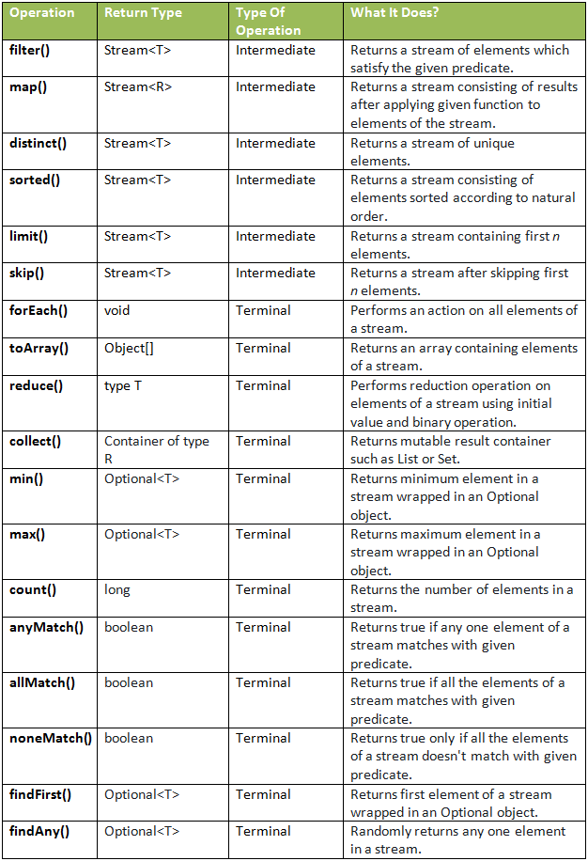

1.1 Filter
SYNTEX:
public Stream filter (Predicate<? super T> predicate)
Definition:
The filter() is an intermediate operation that get the data from a stream and returns a new stream after transforming the data based on the given operation/condition.
->Filter() method is used to filters the elements based upon a given condition
1.2 MAP
SYNTEX:
public Stream map (Function<? super T.? extends R> mapper)
Definition:
map() method is used to produces a new result stream after applying a function to each element of the original stream. The new result stream could be of different type from original stream.
1.3 SORTED:
SYNTEX:
1. Stream<T> sorted (Comparator<? super T> comparator) AND
2. Stream<T> sorted()
Definition:
- It returns a stream consisting of the elements of this stream, sorted according to default natural sorting order.
- It returns a stream consisting of the elements of this stream, sorted according to customize sorting order.
1.4 MIN:
SYNTEX:
1. Optional <T> min (Comparator <? super T> comparator)
Definition :
Returns the minimum element of this stream according to the provided
Comparator.
1.7 toArray:
SYNTEX:
1. Object[] toArray0 2. <A> A[] toArray(IntFunction<A[]> generator)
Definition :
Returns an array containing the elements of this stream, using the provided generator function to allocate the returned array, as well as any additional arrays that might be required for a partitioned execution or for resizing.
what is method reference in Java 8?
Method reference is a shorthand notation of a lambda expression to call a method
numList.stream().filter(n->n>5).sorted().forEach(System.out::println);

What is flatMap in Java?
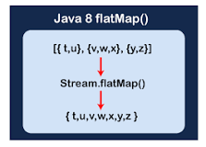
In Java 8 Streams, the flatMap() method applies operation as a mapper function and provides a stream of element values. It means that in each iteration of each element the map() method creates a separate new stream. By using the flattening mechanism, it merges all streams into a single resultant stream.
map() & flatMap()
both these methods are intermediate methods and returns another stream as part of the output.
- Map() method used for transformation.
- flatMap() method used for transformation &flattering.
- Map() takes stream<T> as input and return stream<R>
it’s mapper function produces single value for each input value.
- flatMap() takes Stream<stream<T>> as input and return stream<R>
it’s mapper function produces multiple value for each input value.

What does reduce method do in Java 8?
In Java, reducing is a terminal operation that aggregates a stream into a type or a primitive type. Java 8 provides Stream API contains set of predefined reduction operations such as average(), sum(), min(), max(), and count(). These operations return a value by combining the elements of a stream.

SOLID PRINCIPLES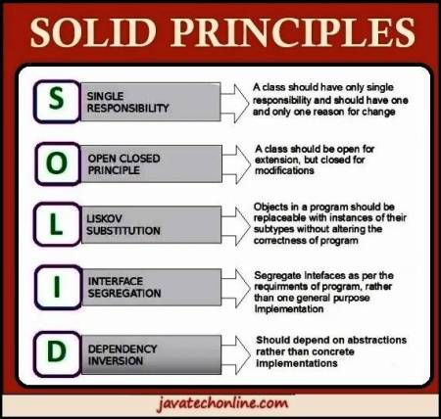
The SOLID principles are five design principles that help make Java code more maintainable, scalable, and easy to understand. They are widely used in object-oriented programming (OOP).

1. Single Responsibility Principle (SRP)
A class should have only one reason to change.
Each class should focus on a single functionality.
2. Open/Closed Principle (OCP)
A class should be open for extension but closed for modification.
You should be able to add new functionality without changing existing code.
3. Liskov Substitution Principle (LSP)
Subclasses should be substitutable for their base classes.
A subclass should not break the behavior of its parent class.
4. Interface Segregation Principle (ISP)
Clients should not be forced to implement interfaces they don’t use.
A class should not be overloaded with methods it doesn’t need.
5. Dependency Inversion Principle (DIP)
High-level modules should not depend on low-level modules. Both should depend on abstractions.

PermGen | MetaSpace
It is removed from java 8. | It is introduced in Java 8.
PermGen always has a fixed maximum size. | Metaspace by default auto increases its size depending on the underlying OS.
Contiguous Java Heap Memory. | Native Memory(provided by underlying OS).
Inefficient garbage collection. | Efficient garbage collection.
Perm Space
Perm Space stands for permanent generation, it is a special type of Heap memory — the JVM stores all the static content in this memory section. This includes all the static methods, primitive variables, and references to the static objects.
MetaSpace
Meta Space is a new type of perm generation memory which came in java 1.8 and replaced the perm generation memory
Major Advantage — This memory region grows automatically by default

What is difference between deep copy and shallow copy in Java?
In Java, shallow copy and deep copy refer to different ways of copying objects. The main difference lies in how object references and their internal objects are handled.
Shallow Copy
- A shallow copy creates a new object but does not create copies of the inner objects.
- Instead, it copies the references to the inner objects, meaning changes to the inner objects in the copied object affect the original object.
Deep Copy
- A deep copy creates a new object and also creates copies of all inner objects.
- Modifying the inner objects of the copied object does not affect the original object.
Use Cases
- Shallow Copy: Suitable when an object’s inner objects don’t need to be modified independently.
- Deep Copy: Needed when independent modifications to the copied object’s fields are required.

Key Differences
Feature | Shallow Copy | Deep Copy
Object References | Copies references to inner objects | Creates new instances of inner objects
Independence | Changes in inner objects affect both original and copied objects | Changes in inner objects of the copy don’t affect the original
Performance | Faster but risky if modifications are needed | Slower but safer for independent copies
Implementation | Uses super.clone() without modifying inner objects | Explicitly clones inner objects

